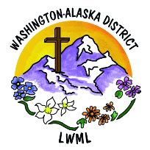
Society Delegate Information Form

Dear LWML Society President/Contact Person:

Please select a voting delegate and an alternate from your society to attend the 2024 Washington-Alaska District Convention to be held on June 21-23, 2024, at the Delta Hotels by Marriott - Seattle/Everette, 3105 Pine Street, Everett, Washington. Complete this Society Delegate Information Form by the due date. Thanks for your cooperation!

After completion, you can scan/email or mail to:
Carolyn Holbrook President
LWML Washington-Alaska District
23516 N Elk-Chattaroy Rd
Colbert, WA 99005
caholbrooklwml@gmail.com 509-481-1101

The form should also be sent to your zone president.
Due: April 15, 2024 – Please complete and return ASAP

Society ___________________________________Zone ___________________________

Delegate
Delegate _________________________________________________________________
Address __________________________________________________________________
City ____________________________________State _________Zip ________________
Phone __________________________ Email ____________________________________
Member in good standing of:
Church Name ______________________________________________________________
City _____________________________________State _________Zip ________________
Pastor’s Signature __________________________________________________________
Alternate Delegate
Alternate _________________________________________________________________
Address __________________________________________________________________
City ______________________________________State ________Zip ________________
Phone __________________________ Email ____________________________________
Member in good standing of:
Church Name ______________________________________________________________
City ______________________________________State ________Zip ________________
Pastor’s Signature __________________________________________________________

